Arts in Mental Health Co-ordinators Report June 2020.

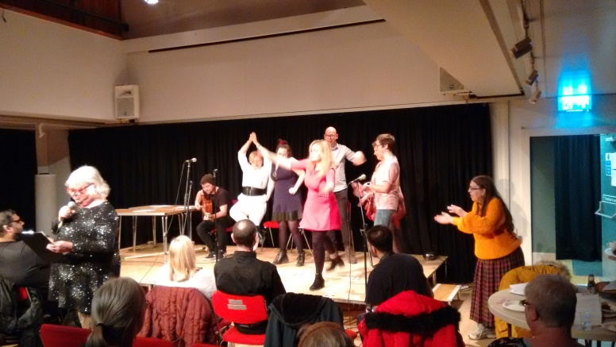

- Introduction.

The Arts in Mental Health Co-ordinators at Leicestershire Partnership NHS Trust, Tim Sayers and Lydia Towsey, have been in post since 2007. The post was initially an Arts Council England funded pilot, but following the overwhelming success of the pilot the co-ordinators have now been firmly established within the Trust for a number of years. This report reflects on the achievements of the co-ordinators over the last twelve months and outlines their plans for the future.

- Background.

- The Co-ordinators have been very successful in attracting external funding into projects that they undertake and also been innovative in finding ways to introduce sustainability into their work.
- They are dedicated to delivering a programme of artistic projects, in partnership with other organisations, across in-patient areas and the community, involving a range of different service users of the Trust.
- They have been highly successful in engaging ‘hard to reach’ and vulnerable mental health service users, continuing to expand their services to encompass new areas of the Trust.
- Their work is essential in delivering an evidence based recovery focused model of care, allowing service users to engage in meaningful activity and to become more of an inclusive part of the communities in which they live.
- The Co-ordinators are dedicated to a programme of research and evaluation of their work, with outcomes contributing to the growing body of evidence that arts in mental health can play a significant role in mental health recovery.
- They have become a very much valued service within the Trust and have promoted a positive image of the Trust, and our service users, to other organisations and the wider community.

- Summary of projects.
Our work can be broken down into two broad categories: NHS delivered ‘in house’ projects and projects delivered in partnership with outside agencies (voluntary, statutory and third sector).
ArtsCafe + ArtSpace.

Popular weekly informal arts workshops, taking place at The Bradgate Mental Health Unit and The Attenborough Arts Centre, targeting people with severe and enduring mental health problems, and dedicated to the production of exhibitions, artworks for display, and for publication. We are successful in engaging considerable numbers of in and out-patients in a range of artistic activities within these groups, introducing them to a rolling programme of projects involving a range of highly talented guest participatory artists.

Bradgate Writers Group + Showcase Collective.

Weekly creative writing groups taking place at the Bradgate Mental Health Unit and The Attenborough arts Centre. Facilitated by Lydia, volunteers Peter Buckley, Jonathan Hurley and Brandon Oliver, and a range of guest facilitators. These popular projects engage large numbers of in-patients and out-patients, and are dedicated to the production of publications, combined with service user performances.

Children of the Asylum, Bogside Story, Beautiful World + ‘Reasonable Adjustment; Disabled Resistance’ projects.

Examples of projects delivered in 2019/20 that have involved members of our different groups working with different participatory artists and creative writers to produce top quality exhibitions, publications and associated performances - both live, and under present Lockdown conditions, online, in high quality and specially produced alternative ways.

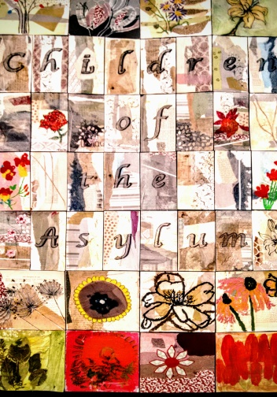

Everybody’s Reading Festival.

Leicester’s festival of books and reading, the two principal objectives of the festival are to promote reading, literacy and associated wellbeing, to the people of Leicester, with an emphasis on engaging vulnerable people. We have been members of the Festival Committee since its’ conception in 2008, when Lydia was first responsible for directing the festival. Since this point we have continued to be involved with delivering various projects as part of the festival. The festival budget for 2020 will be deferred to 2021 when community led events can again take place.
Look-a-Lady Ukulele.

This project targets South Asian women in weekly ukulele based workshops at Peepul Enterprise in Belgrave. Project LALU aims to empower female expression, contribute to cultural cohesion, and improve English literacy.

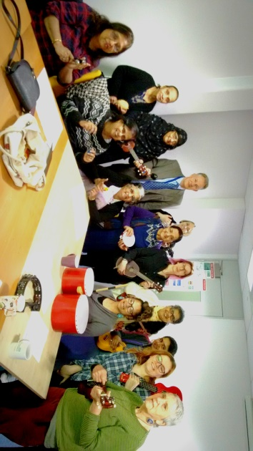

Potential Unlocked.

We have been working in partnership with Soft Touch Arts to deliver a programme of artistic activities, with associated exhibitions and activities, to improve the health and well-being of prisoners at HMP Leicester, HMP Stocken, other regional prisons, and people serving Community sentences. LPT were successful in securing circa £100,000 funding from Arts Council England, with Soft Touch securing further additional funding, to deliver this three year project. This work is subject to three research projects which are being delivered by De Montfort University and The University of Leicester.

Remote Art Project.

Delivered in partnership with BrightSparks: Arts in Mental Health Group, who secured circa £35,000 funding from Leicestershire County Council and Arts Council England. A ‘lockdown’ project dedicated to supporting our more vulnerable service users during this difficult period. The project involves professional artists working over the phone and via email with participants, supporting them to create art, music, comedy, creative writing, and other creative pieces, whilst also providing offering more general social support. Following the lock down, we will celebrate the work created at a special event.

Ward Music Sessions.

During Lockdown Tim has been successfully delivering music sessions on Griffin Ward at The Herschel Prins Centre, The Belvoir PICU, and wards at The Bradgate Mental Health Unit. These involve playing guitar, singalongs, ukulele sessions, teaching sessions, and song writing.

WORD! Online Broadcasts.

Delivered as part of our Remote Art Project, with further funding provided via WORD!’s core Arts Council England budget of £100k flowed over four years (2018 - 2022). This Lockdown outreach project is enabling us to deliver bi-monthly online events, involving and reaching our local service using community, whilst sharing our work with a broader audience.

The Glenvale Gallery, Westcotes Gallery Space, Bradgate and Evington Centre Reception Exhibitions.

The Glenvale Gallery is located at The Bradgate Mental Health Unit and is dedicated to displaying exhibitions of service user art, which then move onto our gallery space at Westcotes Health Centre. We also stage a programme of smaller service user art exhibitions in the reception areas at The Bradgate Mental Health Unit and Evington Centre.

We also regularly stage exhibitions at The Attenborough Arts Centre whilst contributing pieces to their own in-house exhibitions.

Smoothie Service User Sound System.

Weekly Sound System workshops that take place at Stayfree Music Studios at present, but that we are intending to move to The Bradgate Mental Health Unit so it can also benefit in-patients. This project is successful in targeting people from our BAME communities alongside other service users with severe and enduring mental health problems. It has been particularly successful in delivering a programme of performances on different wards at The Bradgate Mental Health Unit and other venues, resulting in direct recruitment of in-patients into the group on their discharge.

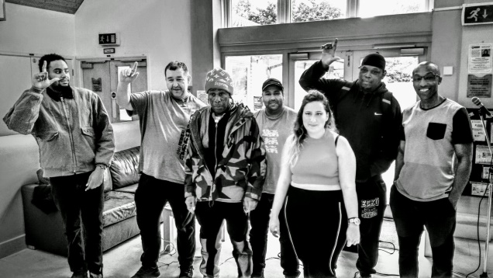

The Comedy Asylum.

Award winning comedy project that culminates in yearly shows as part of Leicester Comedy Festival. BrightSparks: Arts in Mental Health Group were successful in securing circa £185,000 from the Big Lottery Fund in late 2016 to deliver the following over five years;

- Annual Comedy Asylum workshops and show as part of Leicester Comedy Festival.
- Delivery of comedy workshops at The Bradgate Mental Health Unit and other LPT in-patient units.
- Delivery of comedy courses at The Leicestershire Recovery College.
- Expansion of the project to Nottinghamshire, Lincolnshire and Northamptonshire.
- On-going evaluation of the project.
- The Project has been flexible during lockdown in opening up to all, and delivering an on-line platform for people to post comedic material.
- It has also been part of the Remote Art Project, delivering telephone comedy tutorials with service users.

We are also working with Adam Ainsworth, Programme Leader- Drama, at De Montfort University to facilitate longitudinal research around the effectiveness of The Comedy Asylum in successfully delivering recovery focused care.

Every Brilliant Thing.

An on and off-line project delivering weekly inspirations for all artforms which are being displayed on-line or collected at home by the artists themselves. At the end of lockdown this work will be displayed on-line and in public exhibitions.

Every Brilliant Thing 20 Second Poetry Project.

Linked to our Remote Art Project and funded via WORD!, over Lockdown we’ve been gathering 20 second films celebrating brilliant things from service users and the broader community. We’ve asked for 20 seconds to highlight the recommended time to wash your hands, as well as to show how little time it can take to connect and improve someone’s day. Over the last 4 months of Lockdown we’ve social media shared circa 150 of these 20 second films to uplift, unite and connect. Every other month we produce a community film, collating as many extracts from these pieces as possible. See here for more information and our first communal piece https://www.umatterleicester.co.uk/every-brilliantly-worded-thing/

WORD!

WORD is a Leicester based voluntary organisation, delivering one of the longest running poetry events in the UK, continuously active since 2001, alongside an expanding programme of other activities. The organisation is nationally unique in being co-produced by an NHS Trust (Leicestershire Partnership NHS Trust) and is an exceptional example of mental health partnership working. Current funding of £122k (from Arts Council England and other partners) funds a number of our in-patient and out-patient focused poetry projects, as well as a range of newly arising projects targeting other vulnerable members of the community, e.g. Movers Learning Disabled Company, WORD! at The Y (supporting hard to reach 16-21 year old care-leavers) and more. Evaluations produced by University of Leicester and WORD! to follow in 2022.

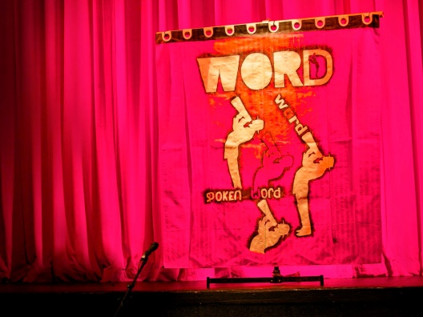
Open Libraries.

We are librarians to a number of open libraries around the Trust, including at The Bradgate Mental Health Unit and The Bennion Centre. We also supply books to the ‘Book Lady’ at The Bradgate Mental Health Unit.
Sounds Aloud Project.

Delivered in partnership with BrightSparks: Arts in Mental Health Group, and funded by The National Lottery, this project has funded our Fosse Music Collective and Smoothie Sound System workshops for one year in delivering a range of performances at mainstream venues dedicated to promoting positive images of mental health and challenging stigma.

Ward Improvement Arts Programme.

In partnership with Soft Touch Community Arts Organisation and funded by the Carlton Hayes Charity this programme is delivered by the highly talented participatory artist Jim Jackson. He has worked with in-patients to design and produce artworks on walls and fences of wards at The Bradgate Mental Unit, The Willows, Stewart House and Mill Lodge. The project is due to undertake work on wards at The Herschel Prins Centre in the near future.

Green Room Gardeners

Green Room Gardeners is a project arising as a result of funding from Kew Gardens and The University of Leicester. The project is led by Leicestershire Partnership NHS Trust and Brightsparks: Arts in Mental Health Group, in partnership with The University of Leicester, Leicestershire and Rutland Wildlife Trust and Attenborough Arts Centre. Our project’s initial objective was to transform Attenborough Arts Centre’s Courtyard from a disused plot - into a green ‘amphitheatre’ garden open to all for relaxation and performances. Having achieved this the group is now moving towards new work across Attenborough Arts Centre, Clarendon Allotments and The Secret Garden based at Glenfield hospital.

The Fearless Fox & Daring Deer

The Fearless Fox & Daring Deer is a rhyming children’s picture book designed to support children and their families and carers to navigate the current COVID-19 pandemic and build emotional wellbeing and resilience. The publication was written by Joe Nixon of Arch Media - with £20k+ of in kind support for marketing, promotion and development. It has been gifted to WORD! who were able to publish it in June 2020 - with all proceeds going to Brightsparks and our partners at Leicester Children’s Hospital. For more information go to www.fearlessfox.co.uk

Sounds Inclusive.

A fully evaluated project previously funded by The National Lottery which encompasses all our performance projects. It is dedicated to employing service users and professional musicians to perform on Mental Health Wards across the trust, conferences, educational venues and at community events.
House of Circus.

With funding from the University of Leicester we are working in partnership with the Enter Eden Community Arts Organisation to deliver an evaluated mental wellbeing programme of weekly circus workshops at The YMCA in Leicester.

Annual Open Art Exhibition.

Now in its’ 20th year, this massively successful and popular annual event, featuring individual and group works, takes place at The Attenborough Arts Centre, then tours to other exhibition spaces that we curate. In 2019/20 the exhibition was called ‘Beautiful World’ and is on tour at present.

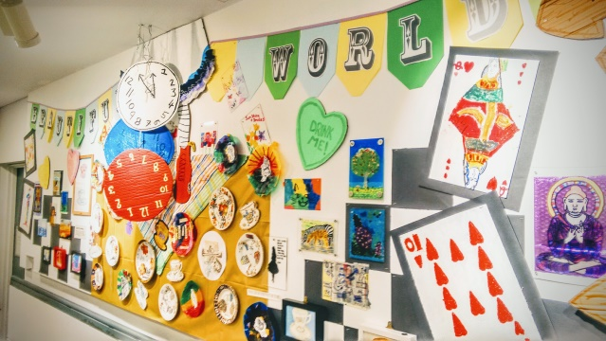

The Elder Tree

The Elder Tree’ project is taking place between 2018 and 2021 and is part of ‘Celebrating Age’ - a programme jointly funded by Arts Council England and the Baring Foundation whilst supporting the shared objectives of both organisations. The programme supports cultural spaces and organisations working collaboratively to do the following;

- Empower older people to help shape what’s on offer or lead quality activities
- Embed proven approaches to engaging older people as visitors, audiences, or participants in creative processes
- Test and apply new ways to engage older people
- Commission older artists or art that has relevance for older people
- Showcase or curate and celebrate art created by and with older people

Current outcomes have included a publication endorsed by Ian Mcmillan and produced by older mental health service users in the community, and diverse communities of vulnerable and isolated older adults reached through Leicester Ageing Together. Further poetry and visual arts based work has recently been undertaken at the Bennion Centre and Evington Centre and will shortly result in tactile sharing books for use at both centres. Further partnership work is scheduled to take place in partnership with UHL.

Towers Heritage Project.

We have supported Charnwood Arts in delivering a project to produce the Towers Heritage Corridor at The Bradgate Mental health Unit alongside artworks which are on display in corridors at the unit.
Fosse Music Collective.

Our very own band of service users meets weekly at The Fosse Community Centre and have successfully performed at a number of public venues, including at The Riverside Festival, Leicester in June 2019. The collective is dedicated to a programme of recording and performing.

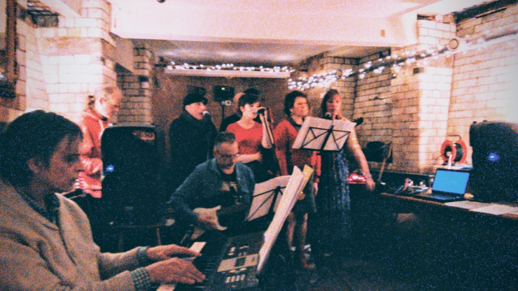

The Packing Saloon.

Taking place at The Bradgate Mental Health Unit, and working in partnership with Giving World Charity, we deliver weekly voluntary packing sessions of toiletry bags for NHS Trusts throughout the UK. At the same time we house an informal group of artists and musicians, delivering a programme of informal music lessons, teaching keyboards, guitar, ukulele and drums to in and out-patients at The Bradgate Mental Health Unit.

Theatre of the Oppressed.

In late 2019 we worked in partnership with BrightSparks: Arts in Mental Health Group and The Attenborough Arts Centre to deliver a series of theatre workshops, facilitated by renowned participatory artist John Berkavitch. The workshops culminated in the production of the ‘I wanna go…’ theatre show, which was performed to a large audience in December 2019. In the meantime, participatory artist, Kirsty Munro continues to deliver Theatre of the Oppressed work at The Herschel Prins Centre.

Mural + Artworks Projects.

Over the last year we have been working with experienced mural artist Scott Bridgwood to improve inpatient and community environments with a range of murals. These have included a complete revamp of the family room at The Bradgate Mental Health Unit, a 62ft long fence mural at Mill Lodge, a new welcome sign mural for the Bradgate MHU, and mural installation at our Attenborough Arts Centre ‘Green Room’ garden.

We continue to provide + display service user artworks on walls at different venues within LPT and also for community venues. At present, we are working with participatory artist Jo Sheppard, to deliver workshops at our ArtsCafe group at The Bradgate MHU, to produce new artworks to improve room environments within the Out-patients department at The Bradgate.

Education, Research and Development.

We have successfully expanded our educational work and provide a number of placements for Mental Health Nursing students throughout the year. We continue to work alongside service users in providing educational sessions to Student Police Officers, Medical Students, Student Social Workers and Occupational Therapist students. Later this year we are hoping to provide a new placement for an arts therapy student. We are dedicated to a programme of evaluation and research of our projects to build on the increasing evidence base of the effectiveness of the arts in delivering recovery focused mental health care.

We deliver a range of successful courses at The Leicestershire Recovery College and have continued this delivery, on-line, during lockdown.

- Income 2019 - 2020.

Project. | Funder. | Sum procured.
Smoothie Sound System | BrightSparks.  Leicester City Council  Carlton Hayes Charity | £388  £1,010  £200
Everybody’s Reading Open Mic. | Everybody’s Reading Festival. | £200
ArtSpace + ArtsCafe | The Attenborough Centre.  BrightSparks  UHL  Carlton Hayes Charity | £1,400  £222  £750  £800
Theatre Project. | BrightSparks.  Attenborough Arts Centre | £40  £2,500
Sounds Inclusive. | BrightSparks  University of Leicester.  Raising Health  Carlton Hayes Charity | £105  £300  £3,000  £1,160
Ukulele Ladies. | University of Leicester.  BrightSparks  Leicester City Council | £150  £40  £500
Fosse Music Collective. | BrightSparks  Leicester City Council. | £169  £750
Ward fence murals | Soft Touch Arts | £7,500
Mural projects | BrightSparks | £4,493
Painting for Wellbeing. | Leicestershire County Council. | £1,500
Green Room Gardeners. | BrightSparks  University of Leicester  Leicester City Council | £731  £750  £962
Packing Saloon | BrightSparks | £80
Bradgate Writers Group | BrightSparks (a further £1994 via the below WORD! budget) | £80
Showcase Smoothie | £1439 via WORD! to cover Slam work and top up Children of the Asylum activity. | Accounted for via the below WORD! budget.
Potential Unlocked | Arts Council England | £32,000
The Comedy Asylum. | BrightSparks  Arts Council England | £516  £35,402
Remote Art | Leicestershire County Council  Arts Council England | £16,450  £24,660
Elder Tree | Writing East Midlands  University of Leicester U.Matter | £10,000  £3,700
WORD! | Arts Council England (total grant - £99,994 flowed over three years)  A further £22,271 from University of Leicester, Carlton Hayes Charity, Attenborough Arts Centre and Inspire Arts brings the total budget to £122, 265 | £49,972 ACE  £138 The Y Ticket sales  £2,929 Attenborough Arts  £1,000 Everybody’s Reading  £600 Inspire  Total - £54,639
Total. |  | £175,179

- Summary.

The Arts in Mental Health Team at LPT have made massive progress in 2019-20 with a considerable expansion in service delivery, mainly achieved through successful partnership working with a number of external agencies and project managers. We are recognized as being a proactive recovery orientated service which responds to identified service user needs, enjoying a very good reputation both within LPT, regionally, and nationally.

- Issues.

- Our major issue continues to be the over popularity of our service which puts increasing pressure on us to deliver more projects whilst, at the same time, endeavoring to source funding to ensure the sustainability of our existing programme of work.
- There continues to be a lack of understanding in some quarters as to the value that the arts can play in supporting recovery in mental health care, this can lead to service users missing out on the opportunities that can be offered from our service.

- Quotes.

‘The sessions were excellent, enlivening, encouraging and brought forth a great deal of talent. I didn’t know I had so much art in me, the group was challenging and stimulating whilst providing a warm and welcoming space in which to participate.’

‘I have found that through this group I have gained confidence especially in speaking out
my opinions and joining in group discussion.’

‘I really enjoyed the workshops they were fun and relaxed and I felt my time there was productive. I am very grateful to everyone concerned, thank you.’

‘I really enjoy being in the group as it makes me feel less alienated and gives me confidence to try other things.’

“Overall a wonderful experience! Well done!”

“Really enjoyed everything. Thanx to everyone involved”

“The best thing I’ve done in 15 years - since leaving college”

“I found that the sessions were delivered very well, and at a good level for all attendees, who were of differing abilities and concentration levels. They were interesting and enjoyable, and both myself and the patient who attended found them rewarding. Thank you for organising and providing the group.”

Lydia Towsey + Tim Sayers
Arts in Mental Health Co-ordinators
Leicestershire Partnership NHS Trust
Beaumont Leys Health Centre
Little Wood Close
LE4 0UZ

Email:
tim.sayers@leicspart.nhs.uk
lydia.towsey@leicspart.nhs.uk
Telephone:
Tim: 07795 475 806
Lydia: 07766 205 689 Produced June 2020.

